Opening Balance Export

Overview 1
G/L History 1
Purge Date 1
Opening Balance Transactions – Financial 1
Opening Balance Transactions – Nominal 1
Outstanding Transactions 1
Matching records 1
Settlement Discount 1
Base Currency 2
Period and Year 2
Details 3
Purge Date 3
Opening Balance Transaction Lines – Financial 3
Outstanding Transactions 3
Opening Balance Transaction Lines – Nominal 4
Opening Balance Transaction Headers 4
Matching Records 4
Temporary Database Files 6
Accumulator (OB_LINES.DAT) 6
Originator (OB_ORIG.DAT) 6
Opening Balance (OB_TRANS.DAT) 6
Opening Balance Matching (OB_MATCH.DAT) 6
Settlement Discounts (OB_DISC.DAT) 6
Diagrams 7
Exporting Financial Transactions 7
Exporting Nominal Transactions 8
Exporting Matching Records 9
Database Structure 10

Overview

G/L History
The existing G/L History export is used to export the Year-To-Date records for all years up to and including the year preceding the drip-feed year. This will not be detailed any further in this document.

Purge Date
The Purge date will be set to the end of the year preceding the drip-feed year, so that the check routines will work correctly.

Opening Balance Transactions – Financial
For periods within the drip-feed year, up to and including the period immediately preceding the drip-feed period, Opening Balance transactions will be created. These will summarise the existing financial transactions, creating an Opening Balance transaction for every Account, Currency, and Debtors/Creditors Control Code. There will be transaction lines for every combination of Cost Centre, Department, and Nominal Code that has transactions against it in the periods being summarised.

Opening Balance Transactions – Nominal
In addition, Opening Balances will be created for Nominal transactions, summarising them by Period and Year -- there will be one Opening Balance transaction for each period up to and including the period immediately preceding the drip-feed period. There will be transaction lines for every combination of Currency, Cost Centre, Department, Vat Type, and Nominal Code that has transactions against it in the periods being summarised.

If the drip-feed begins in Period 1, no Opening Balance transactions are required.

Outstanding Transactions
Any transactions which are unallocated or partially allocated will be brought over in full, rather than being summarised into Opening Balances. All outstanding transactions for periods up the period immediately preceding the drip-feed period will be exported, for all years (hence, these transactions will be exported even if the drip-feed begins in period 1).

All the imported transactions (Opening Balance and outstanding Transactions) will be marked as external.

Matching records
When creating the Opening Balance export, Matching records are created both for the Opening Balance records and for any unallocated or partially allocated Transactions.

Because the matching transactions could be those which have been summarised into Opening Balance records the system keeps track of the original matching records for all transactions that are summarised against each Opening Balance.

Once the Opening Balance records and Outstanding Transaction records have been exported to temporary database files, all the Receipt transactions in this temporary file are checked. The original matching records that relate to these transactions are used to build new matching records, this time matching the transactions in the exported records.

Settlement Discount
Settlement Discount percentages and amounts are stored in the transaction header, and will have to be recalculated for the Opening Balance transactions. Applying the discount percentage to individual lines is not possible, because each Opening Balance will summarise several transactions, which might well have different discount percentages.

Instead, as the transaction lines are summarised, the line totals are calculated ignoring any settlement discount, and the settlement amount from each transaction is stored in a temporary database file.

When the Opening Balance transactions are created, and once all the transaction lines have been added, an additional line is added with the total settlement discount amount, summarised from the details stored in the temporary Settlement Discount database.

This assumes that a transaction cannot appear against more than one SJI/PJI, in other words, that the transaction lines are all against the same Account and Currency and Control Code.

Any settlement discount on transaction lines which are for currency variance are ignored, beause these will appear SJI/PJI transactions for a different currency.

Base Currency
Where transactions are not against the base currency, there may be a discrepancy between the base currency and the transaction currency values. This has to be recalculated when the transaction lines are summarised into the Opening Balances

For each Opening Balance transaction, the Net Value is accumulated for the Transaction Currency, and separately for the Base/Consolidated Currency.

Once all the lines for a transaction are exported, the total Transaction Currency and Base Currency values are compared (converting the Transaction Currency total to Base currency). If there is a discrepancy, another transaction line is added covering the discrepancy, against the Currency Variance G/L Code.

Period and Year
When exporting transactions, the transaction date (and other related dates and periods) is the date of the period immediately preceding the drip-feed period. UDPeriod.DLL is used to obtain the correct dates and periods, so that user-defined periods are taken into account.

Details

Purge Date
The Purge date is specified in the System Settings as the Audit Year. Syss.AuditYr identifies the year that the purge goes up to.

There is also a Syss.AuditPr, but this is always 0.

Opening Balance Transaction Lines – Financial

See Fig.1

All Transaction Lines which are within range (that is, in the drip-feed year and before the start of the drip-feed period) and which are for the same Document Type, Customer/Supplier Code, Currency, Creditors/Debtors Control Account, Cost Centre, Department, and Nominal Code have their values summarised into a single record matching those details.

The document type of the transaction is used to determine the document type of the Opening Balance.

For SIN, SCR, SJI, SJC, and SBT types the Opening Balance will be an SJI.

For PIN, PCR, PJI, PJC, and PBT types the Opening Balance will be a PJI.

For SRI, PPI, SRF, PRF, SRC, and PPY types the Opening Balance will be of the same type.

Transaction lines for all other document types are ignored.

Transaction Lines which have negative Nominal Codes or blank Account codes are ignored.

The first time that a transaction is found against a particular Document Type, Customer/Supplier Code, Currency, Creditors/Debtors Control Account, Cost Centre, Department, and Nominal Code, a new summary line record is created with these details.

The NetValue is recalculated without any discount (this is for dealing with Settlement Discounts), and the resulting value is added to the NetValue of the summary line.

Note: Because the Opening Balance records are divided by currency, the summarised NetValues will always be against the same currency even if they come from separate transactions.

The Customer/Supplier Code, Currency, and Creditors/Debtors Control Account form a unique identifier for the Opening Balance records that will eventually be created, and are combined into an Opening Balance Code that can be used to link the temporary databases.

This Opening Balance Code is stored against each summarised line.

The original Transaction is located, and the Folio Number is stored in a temporary Original Transactions file along with the Opening Balance Code, so that the transactions that have been summarised under each Opening Balance can be located when required, and a flag indicating whether this is an Invoice or a Receipt (for use when exporting Matching records) is assigned.

If a Settlement Discount is specified as having been taken on the original Transaction, the Discount Settlement Amount is stored in a temporary file against the Opening Balance Code.

Outstanding Transactions
As the financial Transaction Lines are processed, any which are found to be for unallocated or partially allocated transactions are not added to the summary. Instead, these transactions are exported in full – the lines are added to the Opening Balance Transaction Lines file, and the header is added to the Opening Balance header file.

An Opening Balance Code is assigned, for consistency with the other records. An entry is added to the Original Transactions file, linking the Opening Balance record back to the original transaction, so that these Outstanding Transactions will be correctly matched when the matching records are created for the Opening Balances.

Putting the Outstanding Transactions into the same file as the Opening Balance records means that the creation of matching records – which needs to be done for these Outstanding Transactions as well as for the Opening Balances – can be handled in the same way for both types of record. Similarly the final export to XML can be done in one pass of these same files.

The only difference is that for Outstanding Transactions the full details (all the fields from the original Transaction Header and Transaction Lines) are stored and exported, whereas for the Opening Balance records only the minimum required information is included.

Opening Balance Transaction Lines – Nominal

See Fig.2

All Nominal Transaction Lines which are within range (that is, in the drip-feed year and before the start of the drip-feed period) and which are for the same Year, Period, Currency, Cost Centre, Department, VAT Code, and Nominal Code have their values summarised into a single record matching those details.

Transaction lines which have negative Nominal Codes are ignored.

The first time that a transaction is found against a particular Year, Period, Currency, Cost Centre, Department, VAT Code, and Nominal Code, a new summary line record is created with these details.

Settlement Discount is not relevant for Nominal transactions.

Matching records are not relevant for Nominal transactions.

A unique Opening Balance Code is created, and assigned to the summarised line.

Opening Balance Transaction Headers
Once all the Opening Balance Transaction Lines have been created, the Opening Balance Transaction Headers can be created.

The Opening Balance Transaction Lines file is traversed in Opening Balance Code order (thus grouping together all the lines that will be against each Opening Balance).

Each time a new Opening Balance Code is found, an Opening Balance header is created, assigning the Opening Balance Code to it and filling in the basic transaction details.

Matching Records

See Fig. 3

The Original Transactions file is traversed. Records which are not for Receipt Transactions are ignored.

For each record, the actual Transaction is located, and the Matching records for the Transaction are retrieved.

For each Matching record we need to find the Opening Balance/Outstanding Transaction record to which it relates. The Original Transactions file includes this information, because for each entry it has both the original transaction and the Opening Balance Code of the record that the transaction was summarised into (or the Outstanding Transaction).

The Original Transactions file is searched for an Invoice record whose OurRef matches the DocCode of the Matching record (because we are processing Receipt transactions, the current Opening Balance transaction will be the payment, and will match with the PayRef in the Matching record).

We now have a pair of Opening Balance records, one for the Invoice and one for the Receipt. Because the Opening Balances are summaries there may well be more than one set of matching records for each Opening Balance record, so the Export Matching file is searched for any existing entry against the combined Opening Balance Codes (as read from the two Opening Balance records), taking the code from the Invoice record as the DocCode, and the code from the Receipt record as the PayRef. If no entry is found, a new Export Matching record is created, and the details are copied from the two Opening Balance records. If an entry is found, the values from the new original matching record are accumulated into it.

Temporary Database Files

See Fig. 4

Accumulator (OB_LINES.DAT)
The Accumulator file holds the accumulated transaction lines, with one record for each DocType, Customer/Supplier Code, Currency, Control Code, Cost Centre, Department, and Nominal Code. On the final export, the Accumulator provides the Transaction Lines for each Opening Balance transaction.

Originator (OB_ORIG.DAT)
The Originator file holds a list of the original transactions that were accumulated into each Accumulator line. Every Accumulator record will have one or more entries in this file, linked via the Opening Balance Code.

It will also include an entry for each outstanding transaction, so that matching records will be automatically exported for these records as well, without special processing.

The outstanding transaction Accumulator lines use the OurRef of the transaction as the Opening Balance Code (as there will only be one entry for each of them in the Accumulator file).

Opening Balance (OB_TRANS.DAT)
Opening Balance is the transaction header file for Opening Balances. This uses the Accumulator file as its transaction line file, linking the records via the Opening Balance Code.

There is one Opening Balance record for each Document Type, Customer/Supplier Code, Currency, and Control Code.

Opening Balance Matching (OB_MATCH.DAT)
The Opening Balance Matching file holds the matching records for each Opening Balance record. The records are built by tracing back through the Originator file to the original transactions and their associated matching records, and accumulating all the records which match to the same pair of Opening Balance records.

The DocCode field holds the Opening Balance Code of the invoice Opening Balance, the PayRef field holds the Opening Balance Code of the receipt Opening Balance.

Settlement Discounts (OB_DISC.DAT)
The Settlement Discounts file maintains a record of all the Settlement Discount amounts that apply to each Opening Balance record, using the Opening Balance Code as the linking field.

When the final Opening Balance records are created, any Settlement Discount amounts for the record are totalled, and a transaction line is added for the total.

Diagrams

Exporting Financial Transactions

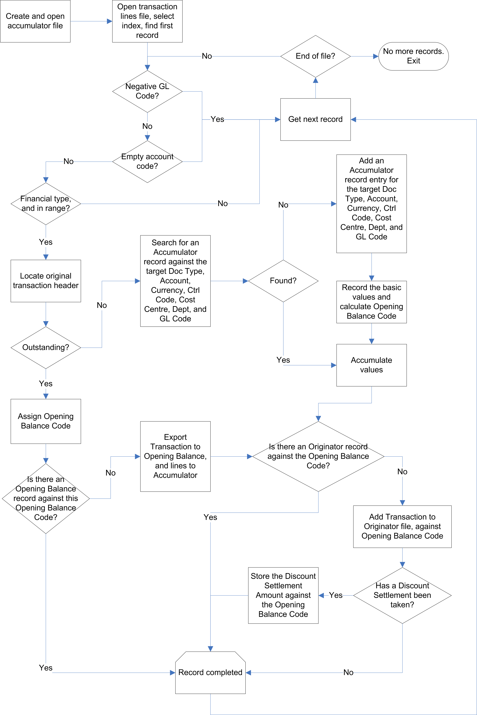

Fig. 1

Exporting Nominal Transactions

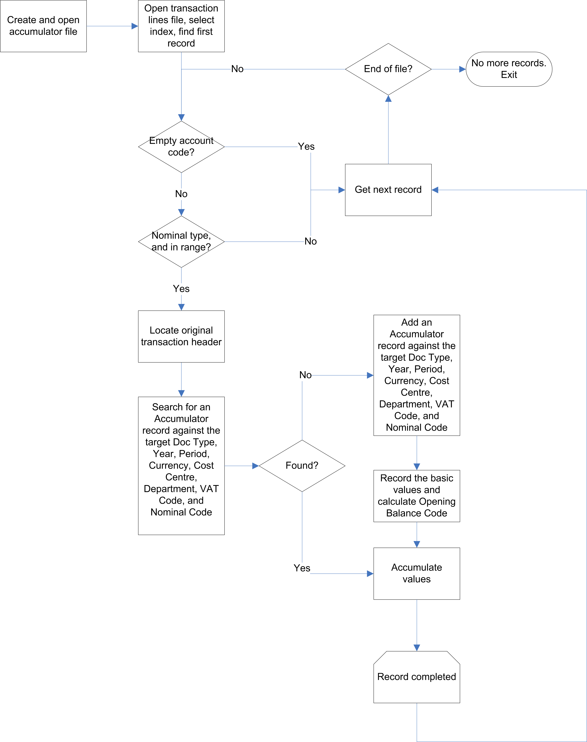

Fig. 2

Exporting Matching Records

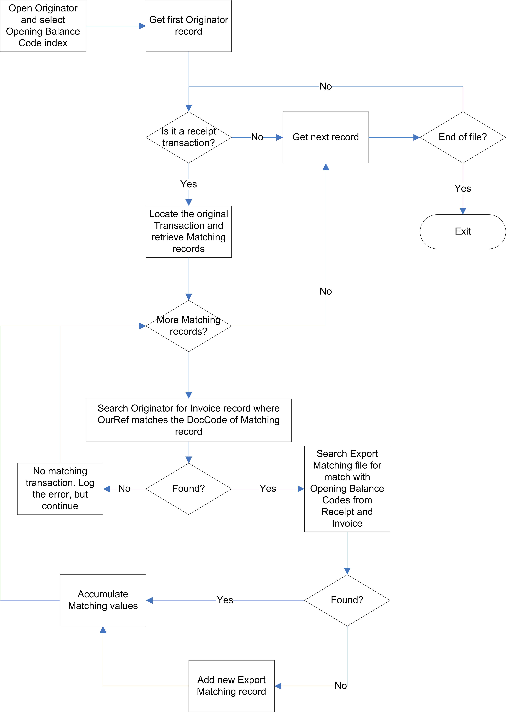

Fig. 3

Database Structure

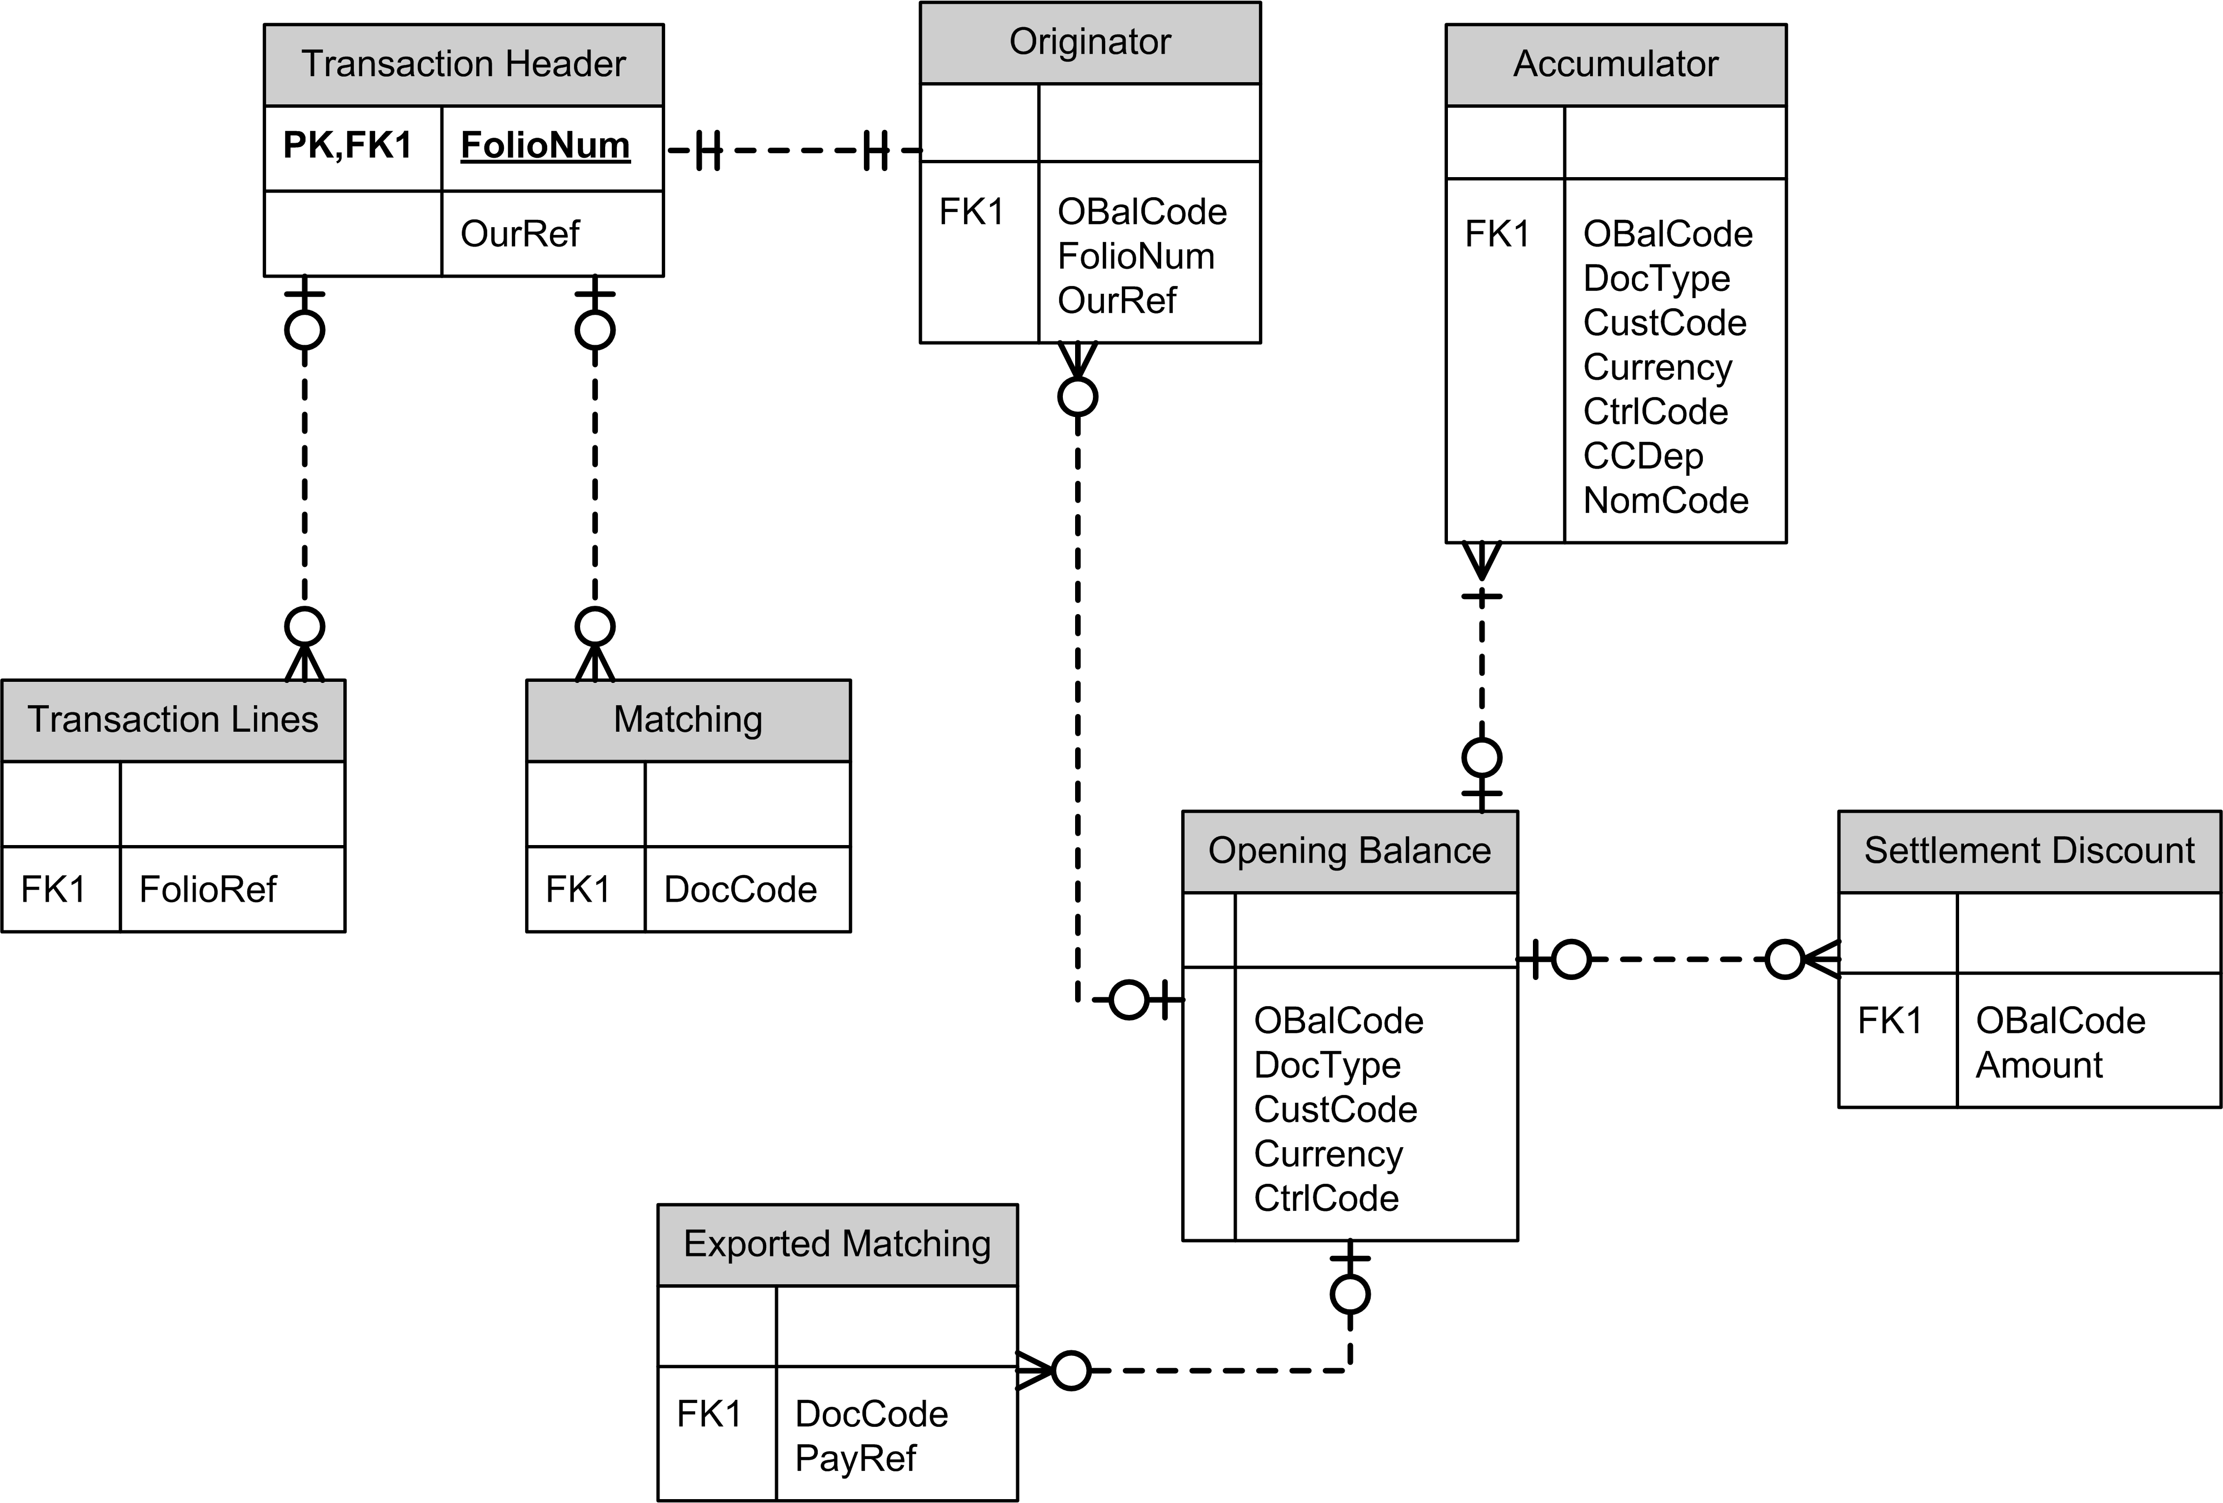

Fig. 4

Note that this diagram only includes the fields which are crucial to the operation of the Opening Balance Export.

